Vrinda Store Data Analysis
Introduction
This project focuses on transforming raw customer-submitted data into meaningful insights. By utilizing a systematic approach, the data underwent cleaning, enhancement, and visualization. The final outputs include actionable dashboards that highlight revenue sources, geographical trends, and product performance, enabling data-driven business decisions.
Purpose
The goal of the project is to:
- Transform raw data into a structured format for analysis.
- Provide actionable insights into customer demographics, sales trends, and regional performance.
- Deliver visual dashboards to aid in decision-making.
Scope
The scope of the project includes:
- Data Cleaning: Ensuring data accuracy and consistency by handling duplicates and formatting errors.
- Data Enhancement: Adding derived fields like age categories and regional classifications for more insightful analysis.
- Visualization: Creating dashboards to summarize key business metrics such as revenue, regional performance, and product trends.
Data Cleaning
The raw data in the "Vrinda Store" sheet was cleaned with the following steps:
- Handling Multi-Line Orders:
  - Duplicate Order IDs indicated multi-line orders where a single order had multiple products (SKUs). All rows were retained, ensuring accurate product-level insights.
- Validation:
  - Checked numeric fields (Amount, Qty) to confirm no invalid or negative values.
  - Ensured no null values in any column.
- Standardization:
  - Unified formats for dates (YYYY-MM-DD) and categorical fields (e.g., Kurta, Set).
- Derived Fields:
- Age Group Categorization
Customers are segmented into the following age groups:
  - Young Adults: Ages 18 to 24
  - Adults: Ages 25 to 64
  - Elderly: Ages 65 and above
This classification aligns with common demographic groupings, where:
  - Young Adults represent individuals in the early stages of adulthood.
  - Adults encompass the prime working-age population.
  - Elderly includes senior citizens.
Such segmentation aids in tailoring marketing strategies and understanding purchasing behaviours across different life stages.
- Regional Categorization
This regional grouping is based on India's administrative divisions and is commonly used for analytical purposes. Shipping states are grouped into zones to facilitate geographical analysis.
The regions and their corresponding states are:
- North Zone: Chandigarh, Delhi, Haryana, Himachal Pradesh, Jammu and Kashmir, Punjab, Uttarakhand, and Uttar Pradesh
- East Zone: Bihar, Jharkhand, Odisha, West Bengal
- South Zone: Andhra Pradesh, Karnataka, Kerala, Tamil Nadu, Telangana
- West Zone: Goa, Gujarat, Maharashtra, Rajasthan
- Central Zone: Chhattisgarh, Madhya Pradesh
- North-East Zone: Arunachal Pradesh, Assam, Manipur, Meghalaya, Mizoram, Nagaland, Sikkim, Tripura
Data Formatting and Manipulation
In the "Processed Data" sheet, the data was further enhanced:
- Additional Columns:
  - Age Category: Added to analyse customer segments.
  - Region: Derived from ship-state for location-based trends.
  - Order-Level Aggregates: Calculated total revenue and quantities for multi-line orders.
- Structure for Pivot Tables:
  - Organized data for easy generation of pivot tables to summarize key metrics.
Key Insights
Pivot Table Analysis (From "Pivot Tables" Sheet):
- Revenue:
  - Total Revenue: ₹21,176,377.
  - Over 31,047 orders processed, selling 31,205 units across all categories.
- Category Performance:
  - Set and Kurta emerged as top-performing product categories.
- Order Channels:
  - Myntra, Amazon, and Ajio contributed significantly to the sales.
Dashboards and Findings
Three dashboards were created for detailed visualization:
- Revenue Sources:
  - Displays contribution by product categories and sales channels.
  - Identifies top revenue generators for strategic focus.
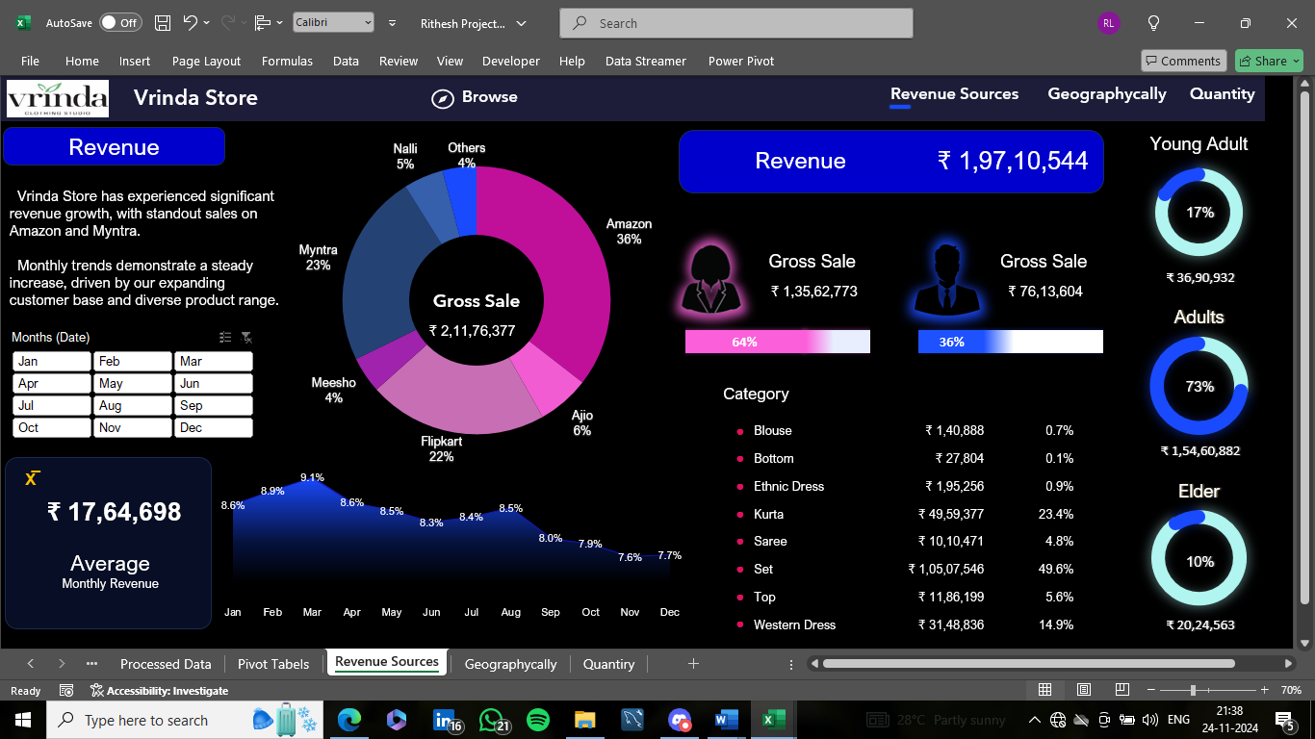
- Geographical Trends:
  - South Zone (Andhra Pradesh, Karnataka, Kerala, Tamil Nadu, Telangana )showed the highest sales.
  - Opportunities exist for expanding in underperforming regions like the North-East.
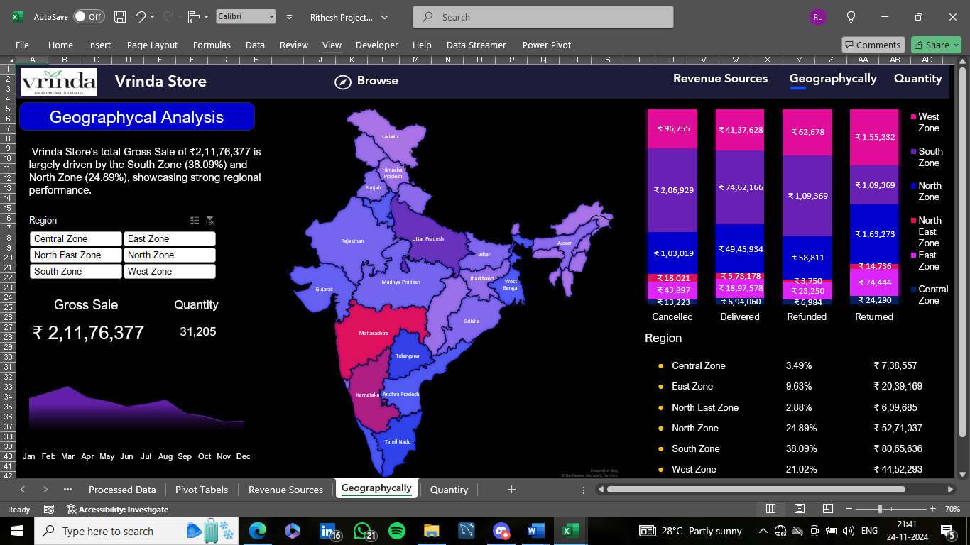

- Quantity Analysis:
  - Highlights top-selling sizes and SKUs.
  - Helps optimize inventory management and reduce stockouts.
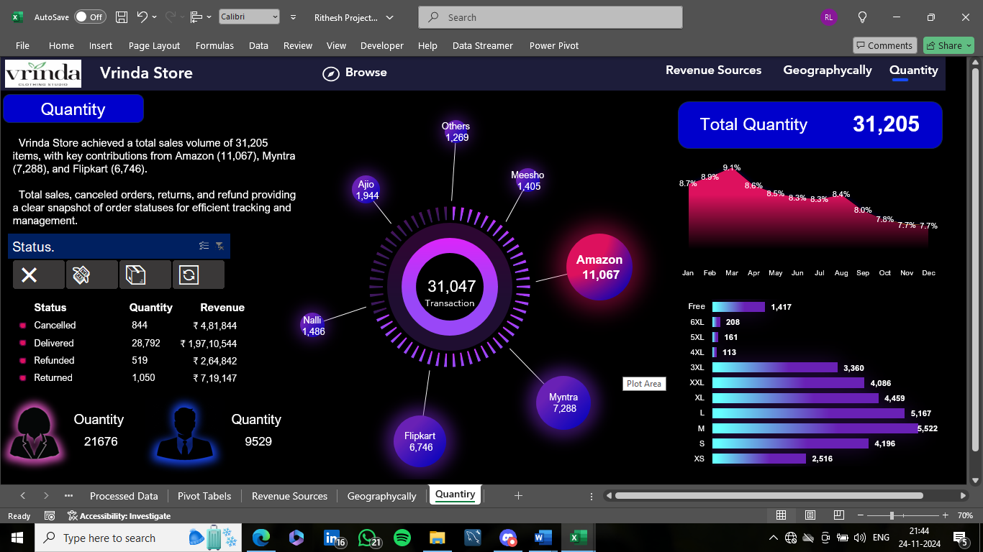

Summary and Recommendations
- Summary:
- The project successfully cleaned, structured, and visualized raw data.
- Multi-line orders were preserved for both order-level and product-level insights.
- Key metrics like total revenue, order count, and regional performance were highlighted.
- Recommendations:
- Target Marketing:
  - Focus on "Women" in the "Adults" age category, who form the majority of customers.
  - Allocate more resources to high-performing channels like Myntra and Ajio.
- Regional Expansion:
  - Increase presence in the North-East and South Zones, which show potential for growth.
- Inventory Optimization:
  - Prioritize restocking high-demand SKUs based on historical quantity trends.

